MEMORANDUM FOR: The Record

FROM: Steven Thur, Ph.D.
Acting Director

SUBJECT: Categorical Exclusion for RESTORE Act Science Program, Award #NA17NOS4510094, “A Web-Based Interactive Decision-Support Tool for Adaptation of Coastal Urban and Natural Ecosystems (ACUNE) in Southwest Florida”

ENCLS: 1) Request for USFWS ESA informal consultation
2) Request for NMFS ESA informal consultation
3) USFWS LOC
4) NMFS LOC
5) Request for EFH informal consultation
6) NMFS EFH LOC
7) Department of the Army permit

NOAA Administrative Order (NAO) 216-6A, Environmental Review Procedures, requires all proposed projects be reviewed with respect to environmental consequences on the human environment. This memorandum addresses the determination that the activities described below for Project #2624084, “A Web-Based Interactive Decision-Support Tool for Adaptation of Coastal Urban and Natural Ecosystems (ACUNE) in Southwest Florida”, qualifies to be categorically excluded from further National Environmental Policy Act review.

Categorical Exclusion Determination

NCCOS determines that this project is covered by the E3 Categorical Exclusion. As defined in the NAO 216-6A Companion Manual, E3 includes activities to collect aquatic, terrestrial, and atmospheric data in a nondestructive manner.

Project Description

Purpose and need

The RESTORE Act Science program is funding a three-year project to University of Florida researchers and sub-awardees to develop a web-based, interactive decision-support tool that enables natural resource and protected area managers and local governments to identify areas of high vulnerability to sea level rise, tropical cyclones and human population growth, and use this information for strategic coastal resiliency planning. Targeted hydrodynamic observations will be used to provide verification and validation data to a suite of coupled state-of-the-art models that will be used to assess vulnerability to these stressors.

Southwest Florida contains the largest area of tidally influenced public lands in the Gulf of Mexico (GOM) and the fastest growing urban landscape in Florida. Both the human and natural components of the regional ecosystem, like others across the Gulf of Mexico, are under increasing risk due to the threats of a growing human population, sea level rise (SLR), and tropical cyclones (TC), which are predicted to become more intense and frequent and increase salt water inundation.

This project will develop two primary products. First, using a suite of coupled state-of-the-art models, it will create inundation maps, salinity distribution maps, habitat distribution maps, beach and barrier islands vulnerability maps, and economic impact maps for both current and future climates and for various sea level rise scenarios specific to this region. Second, it will integrate the maps into an Adaptation of Coastal Urban and Natural Ecosystems (hereafter, ACUNE) web-based interactive decision-support tool that enables users to identify areas of high vulnerability in many layers of interest and use this information for strategic coastal resiliency planning. Rookery Bay NERR’s Coastal Training Program will host ACUNE workshops to train end-users on how to use this tool. Ultimately ACUNE will allow the end users to make decisions in coastal planning, zoning, land acquisition, and mangrove/marsh restoration that are based on models that are far more rigorous than those currently available (e.g., FEMA flood maps).

The project will develop these products through the following tasks:
- End-user & researcher coordination and integration: through an initial planning and follow-up workshops and meetings. (Office-Based)
- Mapping of vegetation distribution and structure, in both horizontal and vertical directions (Field Sampling)
- Conduct field experiments to obtain data for Advanced Coastal Modeling System (ACMS) verification and validation (Field Sampling)
- Validate the vegetation-resolving ACMS (Office-Based)
- Develop surge-wave-inundation maps under current and future climate (Office-Based)
- Predict estuarine salinity in future climate (Office-Based)
- Predict breaching and overwash potential of barrier islands and the future distribution of tidally influenced mangrove forest and salt marsh (Office-Based)
- Develop the future coastal inundation and economic impact maps (Office-Based)
- Develop the ACUNE interactive tool (Office-Based)

Action Area:
The Action Area for this project will be coastal southwest Florida (Figure 1), particularly Collier County, the city of Naples, within Rookery Bay National Estuarine Research Reserve (RBNERR) and Ten Thousand Islands National Wildlife Refuge (TTINWR). A total of 18 sites in the RBNERR and TTINWR will be instrumented as part of this project.

Project Activities:
Of the nine (9) tasks for this project listed above, all but two of them (#’s 2 and 3) will occur in an office setting using computers. Tasks 1 and 4 to 9 involve activities to be conducted in an office setting such as workshops, modeling, model validation, predictive map development, data synthesis and development of interactive tools. Tasks #2 and 3 involve field work that is of more concern for this NEPA analysis and these will be described in greater detail below.

- Task 2 - Mapping of vegetation distribution and structure, in both horizontal and vertical directions

They will use other high-resolution maps that document the composition of plants in the region to identify five representative locations within each of four vegetation types (mangrove forest, mangrove woodland, mangrove shrub/scrub, and graminoid salt marsh) in RBNERR and TTINWR to conduct these studies. Mangrove forest and mangrove woodland sites will be accessed by boat with the help of RBNERR staff and the mangrove shrub/scrub and marsh sites will be accessed by foot.

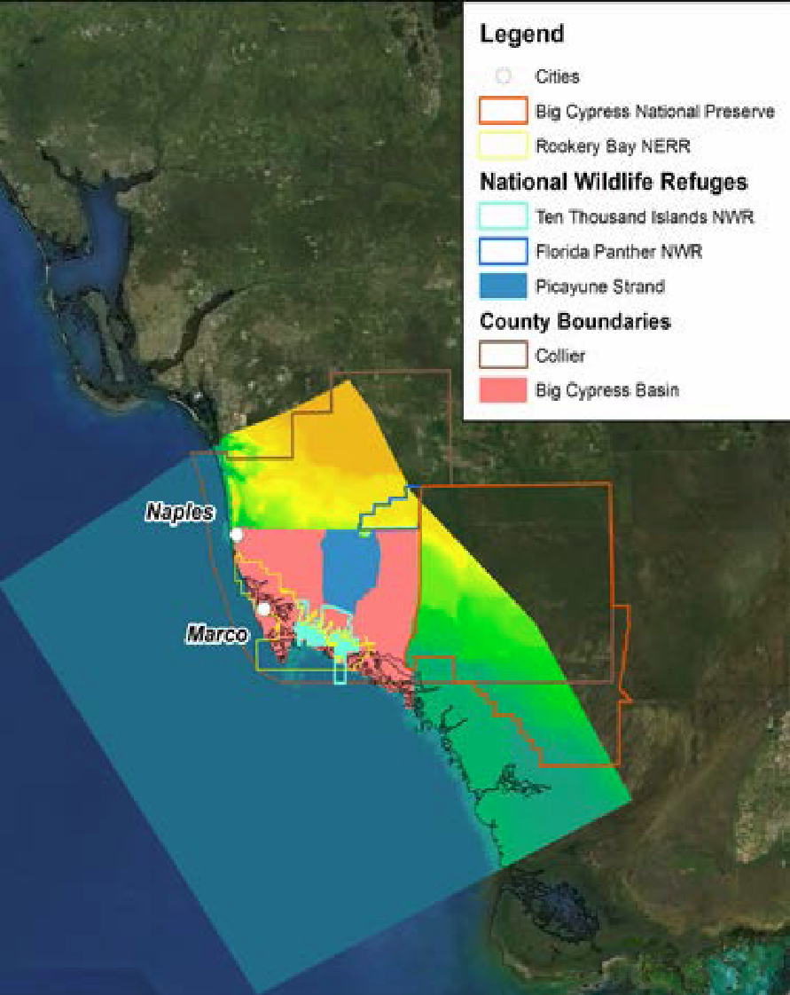
Figure 1. Southwest Florida study area with cities, counties, and larger protected areas identified. Everglades National Park is south of the Big Cypress National Preserve.

Researchers will use a terrestrial LiDAR scanner (TLS) integrated with an 8 mega-pixel camera and Real Time Kinematic GPS to image and measure geographic location, surface elevation, and the vertical structure of the vegetation canopy in the dominant wetland plant community types in the region. Data gathered will be returned to the lab for analysis for other tasks in the project. The TLS, GPS and camera mount on a portable tripod and are carried by researchers. At each location, the TLS will collect data from 3 replicate 10 x 10 m areas (thus 15 replicate scans per community type). At each location, plant composition and canopy height will also be characterized with traditional visual methods within 4 replicate, 1m x 1 m survey quadrats within marsh and mangrove shrub/scrub habitats and within 3m x 3m quadrats within mangrove forest and woodland habitats.

- Task 3 - Conduct field experiments to obtain data for Advanced Coastal Modeling System (ACMS) verification and validation
  - To assess the effects of coastal wetlands on energy dissipation during episodic events and enable verification and validation of the ACMS, the researchers will collect hydrodynamic observations in two regions: a) contiguous natural habitat; and b) natural and nature-based features (NNBFs). A total of 28 wave/surge pressure gages will be developed, built and deployed. The monitoring locations will be positioned to capture the natural habitat features that align with critical management questions and minimize accessibility issues. Some of the 28 monitoring locations may overlap with those from Task 2, but most will be different. They will span a larger geographic area than the vegetation mapping.

  - Locations developed in Task 1 are based on:
    - How well the location represents mangrove forest, mangrove woodland, mangrove shrub/scrub, or graminoid salt marsh in contiguous natural habitat and around NNBFs,
    - Anticipated inundation at the location based on historical knowledge and preliminary modeling;
    - Ease of physical access; and
    - the ease of obtaining permission from appropriate state or federal agencies to both travel to and deploy instruments at the location.

  - Data collected will enable the determination of surge/tide level, wave height, and frequency. Gages will be time synchronized to ensure that relevant flooding pathways can be determined. A field team will deploy gages before at the start of the project and recover them after the final observation event or at the conclusion of the project, whichever comes first. Periodic equipment maintenance trips (approximately every 3 to 6 months) will be conducted to check the health of the equipment.

  - The wave/surge sensors consist of a pressure sensor, a microcontroller, a micro SD card, two alkaline battery packs, a water detection switch and supporting circuitry. These components will be placed in small (<3’ in length) watertight 3” PVC enclosure. The enclosure will be attached to a rigid structure or tree using a stainless steel worm-drive clamp, or be directly anchored to the ground using a galvanized steel earth auger anchor capable of hundreds of pounds of holding force. All components will have appropriate contact information on them.

  - The pressure sensor and water detection switch will be positioned vertically such that both are above MHHW. During typical water level conditions, the device will remain in “sleep” mode consuming minimal amount of power. Only after rising waters trigger the water detection switch will the device become “active” and start recording. If no events occur, the batteries will enable the device to stay in sleep mode for 10+ years, longer than the expected life of the batteries. Recording at 100 hz, the batteries should be capable of record 2-4 weeks of continuous data.

  - Initially, a field deployment team will use a small boat to travel the observation sites using easily navigable waterways, install the sensors, and then survey their positions using nearby landmarks and GPS (horizontally and vertically). These sensors will remain in place for the duration of the study. Depending on availability, field boats will be either be provided by UF or by the NERR. A NERR boat will include an operator provided by the NERR. NERR boat operators are familiar with local geography, habitat, fauna, species and taxa.

  - Four events will be targeted for observation throughout the course of this project, including high water level events caused by a tropical cyclone, a large front; and abnormal high tide. Realistically, the region may only be impacted by very few storms during the project; hence the inclusion of other high-energy episodic events which can be guaranteed to occur. Ideally, the researchers will be able to obtain data from at least one of each type; however, if the southeast portion of the Gulf remains inactive, then an alternative plan would be to target 2 fronts and 2 high tides.

  - Shortly after an event (on the order of days/weeks later), a field team will be deployed to recover data from the sensors, leaving them in-place for use in the next event.

  - After completion of the final observation event, when the sensors will be recovered, the field team will re-survey and then remove any mounting hardware (e.g. screw anchors). With the sensors being above MHHW (thus, only being exposed to the biologically rich water for a short period of time) and the mounting hardware being stainless or galvanized, it is anticipated that all components will have a lifespan sufficient to at least last through the entire scheduled observation event. With accurate GPS measurements, recording of near-by landmarks, it is anticipated that all deployed sensors will be recoverable.

Effects of the Project, Environmental Statutes & NCCOS Determination of Effects:

Most activities (tasks 1, 4-9) associated with this project would be conducted in an office setting using data, statistical algorithms, modelling software and meetings/workshops within existing facilities using existing infrastructure and would have no impact on the human environment.

The LIDAR mapping and photography of vegetation distribution and structure is strictly terrestrial besides the use of small boats to access mangrove forest and woodland sites. The equipment is all portable, not left in the field, and poses no risks itself; the main terrestrial risks are to habitat. The main aquatic risks are from boat strikes.

The field experiments to obtain data for Advanced Coastal Modeling System (ACMS) verification involve boat access to field sites and then walking in intertidal areas to deploy the wave gage platforms and sensors. The sensors and platforms are small in size and have no sharp surfaces and pose no entanglement risk so the main risks are damage to habitat and boat strikes.

Endangered Species Act (ESA) Section 7 (a)(2) requires that each Federal agency, in consultation with NMFS and/or the U.S. Fish and Wildlife Service (USFWS), ensure that any action authorized, funded, or carried out by the agency is not likely to jeopardize the continued existence of any endangered or threatened species or result in the destruction or adverse modification of designated critical habitat.

The terrestrial research activities potentially occur in the range of a number of ESA listed species under the authority of USFWS (Table 1). This list includes nine (9) birds, one (1) reptile, seven (7) flowering plants, two (2) insects, and seven (7) mammals. The birds of most concern are the shorebirds: piping plover and red knot. The researchers will not sample in piping plover critical habitat. Researchers will avoid sampling when crocodiles are within 50 yards.

The aquatic field research activities potentially occur in the range of one ESA listed marine mammal under the authority of USFWS. That species is the West Indian manatee (Trichechus manatus). The West Indian manatee is currently listed as threatened. The manatee has critical habitat designated in Florida waters in the Gulf of Mexico (Figure 2). The project will avoid sampling in designated critical habitat. The project is unlikely to adversely affect manatees because of the avoidance and monitoring BMPs, the short duration, slow speed, small temporal footprint of the work, and the lack of protruding or entangling risks from the platforms and gages, therefore, NCCOS determines that research activities and vessel transit would not adversely affect West Indian manatees or destroy or adversely modify designated critical habitat.

NCCOS initiated an informal ESA Section 7 consultation with USFWS on April 14, 2017 requesting concurrence with our determination (Encl 1). On May 2, 2017 NCCOS received a letter of concurrence from USFWS with the determination of may affect, not likely to adversely affect ESA-listed species or designated critical habitat (Encl 3). Further consultations on this action are not necessary unless future modifications to activities are proposed that may result in adverse impacts to ESA-listed species or their critical habitat.

Table 1. Gulf of Mexico's Threatened and Endangered Species (project area) under USFWS jurisdiction.
Status | Name | Critical Habitat
Birds
Threatened | Audubon's Crested Caracara Polyborus plancus audubonii | N/A
Endangered | Bachman's Warbler (=wood) Vermivora bachmanii | N/A
Endangered | Cape Sable Seaside Sparrow Ammodramus maritimus mirabilis | N/A
Endangered | Everglade Snail Kite Rostrhamus sociabilis plumbeus | https://ecos.fws.gov/ecp/species/7713
Endangered | Ivory-billed Woodpecker Campephilus principalis | N/A
Threatened | Piping Plover Charadrius melodus | https://ecos.fws.gov/ecp/species/6039
Threatened | Red Knot Calidris canutus rufa | N/A
Experimental | Whooping Crane Grus americana | N/A
Threatened | Wood Stork Mycteria americana | N/A
Reptiles
Threatened | American Crocodile Crocodylus acutus | https://ecos.fws.gov/ecp/species/6604
Flowering Plants
Endangered | Aboriginal Prickly-apple Harrisia (=Cereus) aboriginum (=gracilis) | N/A
Threatened | Blodgett's Silverbush Argythamnia blodgettii | N/A
Endangered | Cape Sable Thoroughwort Chromolaena frustrata | https://ecos.fws.gov/ecp/species/4733
Proposed Threatened | Everglades Bully Sideroxylon reclinatum ssp. austrofloridense | N/A
Endangered | Florida Semaphore Cactus Consolea corallicola | N/A
Endangered | Key Tree Cactus Pilosocereus robinii | N/A
Endangered | Wedge Spurge Chamaesyce deltoidea serpyllum | N/A
Insects
Endangered | Miami Blue Butterfly Cyclargus (=Hemiargus) thomasi bethunebakeri | N/A
Endangered | Schaus Swallowtail Butterfly Heraclides aristodemus ponceanus | N/A
Mammals
Endangered | Florida Bonneted Bat Eumops floridanus | N/A
Endangered | Florida Panther Puma (=Felis) concolor coryi | N/A
Endangered | Key Deer Odocoileus virginianus clavium | N/A
Endangered | Key Largo Cotton Mouse Peromyscus gossypinus allapaticola | N/A
Endangered | Key Largo Woodrat Neotoma floridana smalli | N/A
Endangered | Lower Keys Marsh Rabbit Sylvilagus palustris hefneri | N/A
Endangered | Rice Rat Oryzomys palustris natator | N/A

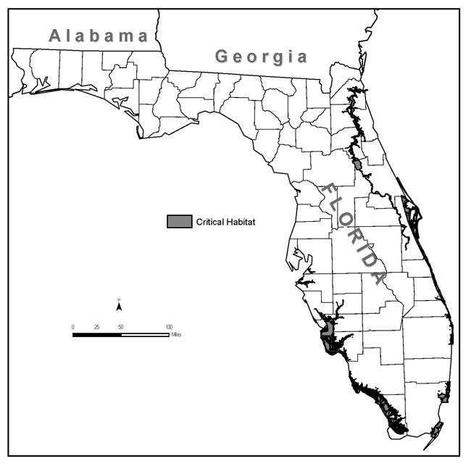
Figure 2. West Indian manatee critical habitat.

There are a total of seven (7) species of corals, five (5) marine mammal species (details under MMPA section below), five (5) turtle species and six (6) fish species listed under ESA within the Gulf of Mexico (GOM) under NMFS’ jurisdiction (Table 2). These species are listed as either endangered, threatened, candidate, or proposed. The distribution of corals is not expected to overlap with the research action area and vessel transit will have no adverse impacts on these species. Therefore, corals will not be analyzed further in this memorandum.

The research activities and vessel transit are not expected to have adverse impacts on the listed fish species except potentially smalltooth sawfish. The only risk to the species themselves is vessel transit and there is no expected effect of vessel transit on fishes. Smalltooth sawfish however do have critical habitat that overlaps with the southern portion research area (see Figures 1 and 3). Two physical and biological features are identified as essential to the conservation of the smalltooth sawfish. The two features are: red mangroves and shallow euryhaline habitats characterized by water depths between the Mean High Water line and 3 ft (0.9 m) measured at Mean Lower Low Water (MLLW). Sampling and gage placement will occur in these habitats. NCCOS determines that the research activities may affect, but are not likely to adversely affect smalltooth sawfish critical habitat because of the small temporal and spatial scale of the gages and platforms, the negligible risk the gages and platforms pose to the habitat, and the otherwise limited disruption to the euryhaline habitat essential feature.

Research activities are not expected to have adverse impacts on sea turtles. The primary concern is a boat strike during transit between stations and to the various ports. Best Management Practices (see below) are included so capture and harm to turtles is highly unlikely.

Loggerhead sea turtles (Caretta caretta) have critical habitat designated throughout the Gulf and in southwest Florida (see here). The only component of critical habitat that overlaps the research area is the nearshore reproductive habitat. The physical and biological features of nearshore reproductive habitat is “a portion of the nearshore waters adjacent to nesting beaches that are used by hatchlings to egress to the open-water environment as well as by nesting females to transit between beach and open water during the nesting season.” Primary Constituent Elements that support this habitat are “the following:

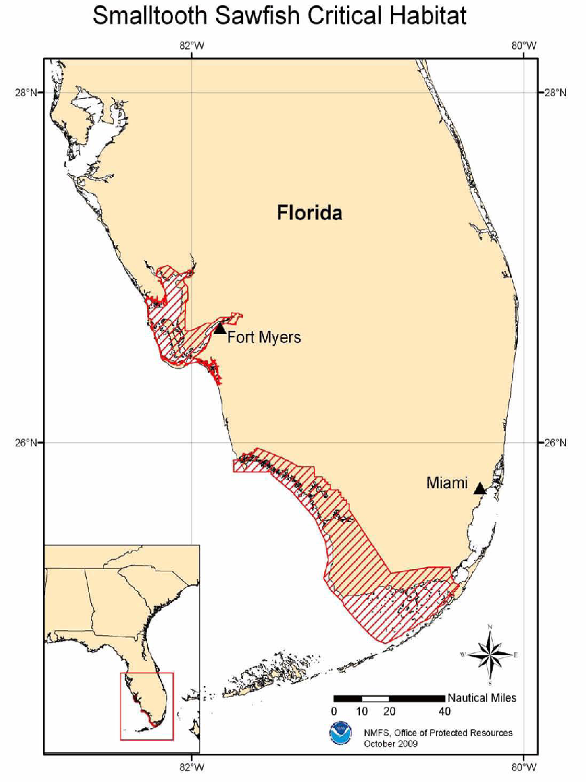
Figure 3. Smalltooth sawfish critical habitat.

(1) Nearshore waters directly off the highest density nesting beaches and their adjacent beaches as identified in 50 CFR 17.95(c) to 1.6 km (1 mile) offshore;
(2) Waters sufficiently free of obstructions or artificial lighting to allow transit through the surf zone and outward toward open water; and
(3) Waters with minimal manmade structures that could promote predators (i.e., nearshore predator concentration caused by submerged and emergent offshore structures), disrupt wave patterns necessary for orientation, and/or create excessive longshore currents.

The proposed research activities would not affect any of the PCEs and would involve only boat transit through the critical habitat areas. Therefore, NCCOS determines that research activities and vessel transit would not adversely affect sea turtles or destroy or adversely modify designated critical habitat for loggerhead sea turtles.

Marine Mammal Protection Act (MMPA) - All marine mammals are protected under the MMPA. Sections 101 (a)(5)(A) and (D) allow the incidental take of marine mammals only under special circumstances, where “take is defined as “to harass, hunt, capture, or kill, or attempt to harass, hunt, capture, or kill any marine mammal” (16 U.S.C. §1361-1421h). Harassment includes any annoyance which has the potential to injure a marine mammal or stock (Level A) or disrupt its behavioral patterns (Level B).

There are six (6) total species of threatened and endangered marine mammals whose potential ranges overlap with the action area of the research activities (Table 2). These include manatees (discussed above), Blue Whale (Balaenoptera musculus), Fin Whale (Balaenoptera physalus), Sei Whale (Balaenoptera borealis), Sperm Whale (Physeter microcephalus), and Bryde’s Whale (Balaenoptera edenii). The proposed research activities do not overlap with the typical habitat of these other species as the research activities will occur in very shallow water. Further, while small vessels are used to transit to site locations, these vessels are used routinely in research operations and do not represent an increased risk to marine mammals. Protective measures incorporated into this project include maintaining safe distances from marine mammals spotted during the course of research and transit, maintaining safe speeds and avoiding entanglement risks (see below). Therefore NCCOS determines that project activities would have no effect on marine mammals generally or ESA-listed species of marine mammals.

NCCOS initiated an informal ESA Section 7 consultation with NMFS on April 14, 2017 requesting concurrence with our determination (Encl 2). On June 23, 2017 NCCOS received a letter of concurrence from NMFS Office of Protected resources (OPR) with the determination of ‘may affect, not likely to adversely affect’ ESA-listed species or designated critical habitat (Encl 4). Further consultations on this action are not necessary unless future modifications to activities are proposed that may result in adverse impacts to ESA-listed species or their critical habitat.

Table 2. Gulf of Mexico's Threatened and Endangered Species (Florida Bay to Texas border, includes Flower Gardens Banks) under NMFS’ jurisdiction (http://sero.nmfs.noaa.gov/protected_resources/section_7/threatened_ endangered/Documents/gulf_of_mexico.pdf)
Status | Species Name | Critical Habitat (in Gulf of Mexico)
Corals
T | Lobed Star Coral (Orbicella annularis) | N/A
T | Boulder Star Coral (Orbicella franksi) | N/A
T | Mountainous Star Coral (Orbicella faveolata) | N/A
T | Pillar Coral (Dendrogyra cylindrus) | N/A
T | Rough Cactus Coral (Mycetophyllia ferox) | N/A
T | Elkhorn Coral (Acropora palmata) | Yes, linked here
T | Staghorn Coral (Acropora cervicornis) | Yes, linked here
Mammals
E | Fin Whale (Balaenoptera physalus) | N/A
E | Sei Whale (Balaenoptera borealis) | N/A
E | Sperm Whale (Physeter macrocephalus) | N/A
PE | Bryde’s Whale (Balaenoptera edenii) | N/A
Sea Turtles
T | Green Turtle (Chelonia mydas) | N/A
E | Hawksbill Turtle (Eretmochelys imbricata) | N/A
E | Kemp’s Ridley Turtle (Lepidochelys kempii) | N/A
E | Leatherback Sea Turtle (Dermochelys coriacea) | N/A
T | Loggerhead Sea Turtle (Caretta caretta) | Yes linked here 38 designated marine areas in the southeast (includes GOM)
Fishes
T | Gulf Sturgeon (Acipenser oxyrhynchus desotoi) | Yes, linked here
E | smalltooth sawfish (Pristis pectinata) | Yes, linked here
T | Nassau grouper (Epinephelus striatus) | N/A
PT | Giant Manta (Manta birostris) | N/A
C | Dwarf Seahorse (Hippocampus zosterae) | N/A
PT | Oceanic Whitetip Shark (Carcharinus longimanus) | N/A
E = Endangered, T = Threatened, C = Candidate, P = Proposed.

Magnuson-Stevens Fishery Conservation and Management Act (see this) requires that Federal agencies consult with NMFS on actions that “may adversely affect” Essential Fish Habitat (EFH) (16 U.S.C. §1855(b)(2)).

NCCOS examined two sources from the NOAA Office of Habitat Conservation (OHC) to conduct this analysis of potential impacts to EFH. NCCOS consulted the NOAA OHC, EFH mapper and the 2015 Final Essential Fish Habitat 5-Year Review for Atlantic Highly Migratory Species. The EFH Mapper sources indicated that there is no coral EFH within the research activity area. However, both sources indicated the following species groups or taxa potentially have EFH designated within the research activity area (Figure 1) as follows:

Species or Taxa within Research area:
- Shrimp
- Coastal Migratory Pelagics
- Reef fish
- Atlantic sharpnose shark
- Blacknose shark
- Blacktip shark
- Bonnethead shark
- Bull shark
- Greater hammerhead shark
- Scalloped hammerhead shark
- Lemon shark
- Nurse shark
- Sandbar shark
- Spinner shark
- Tiger Shark

In addition, no Habitat Areas of Particular Concern (HAPC) and no EFH areas closed to fishing overlap with vessel transit or research activity areas (Figure 1).

Based on research activities and the potential EFH that could be encountered, NCCOS determines that no adverse effects to EFH, either direct or indirect, would occur within the proposed research action or transit area as the work is of short duration, will not affect the substrate and will cover a limited area of habitat. NCCOS would use BMPs (last section) when or if anchoring is needed to avoid impacting EFH

NCCOS initiated an informal EFH consultation with NMFS Southeast Region Office (SERO) on March 29, 2017 requesting concurrence with our determination (Encl 5). On May 11, 2017, NCCOS received an LOC from NMFS SERO concurring with the NCCOS determination of no adverse affects to EFH (Encl 6). The LOC states that further EFH consultation on this action is not necessary unless future modifications to activities are proposed that would result in adverse impacts to EFH.

Are there any protected area permits required also?

Pursuant to Section 404 of the Clean Water Act, NCCOS partners are currently working under the USACE exemption letter, SAJ-2017-03269 (Encl 7). This exemption states “ the project as proposed will not require a Department of the Army permit in accordance with Section 10 of the Rivers and Harbors Act of 1899 as it is not located within the navigable waters of the United States. Furthermore, a permit will not be required in accordance with Section 404 of the Clean Water Act as it will not involve the discharge of dredged or fill material into waters of the United States. Provided the work is done on the said properties and no fill or discharge will exit the properties, Department of the Army authorization will not be required.” Thus, NCCOS determines that no further action is required to fill the Clean Water Act requirements.

Extraordinary Circumstances

No activities will be conducted in areas where children may congregate. The proposed project does not involve air, noise, or water quality impacts; and does not otherwise have a significant impact on the human environment that is not negligible or discountable. There are no adverse effects on an area with unique environmental characteristics that are not negligible or discountable. In addition, project activities related to the long-term deployment and recovery of the scientific instruments are permitted by a joint Florida USACE Nationwide Permit 5 for scientific instruments (#xxx-2014-xxxx, expiration x/xx/2018) There are no adverse effects on species or habitats protected by the ESA, the MMPA, the MSA, NMSA, or the Migratory Bird Treaty Act that are not negligible or discountable. The proposed project has no potential to generate, use, store, transport, or dispose of hazardous or toxic substances in a manner that may have a significant effect on the environment. There are no adverse effects on properties listed or eligible for listing on the National Register of Historic Places authorized by the National Historic Preservation Act of 1966, National Historic Landmarks designated by the Secretary of the Interior, or National Monuments designated through the Antiquities Act of 1906; Federally recognized Tribal lands, cultural or natural resources, or religious or cultural sites. The proposed project does not have a disproportionately high and adverse effect on the health or the environment of minority or low-income communities, compared to the impacts on other communities (EO 12898). The project will not contribute to the introduction, continued existence, or spread of noxious weeds or non-native invasive species known to occur in the area or involve actions that may promote the introduction, growth, or expansion of the range of the species. There is no potential to violate Federal, State, or local law or requirements imposed for protection of the environment. There are no highly controversial environmental effects. These activities are not the subject of controversy based on potential environmental consequences and do not establish a precedent or decision in principle about future proposals. Thus, there are no extraordinary circumstances present that may require further analysis in an EA or EIS.

Protective Measures and Best Management Practices Incorporated into the Action

The following protective measures and BMPs will be incorporated into the research plan and are listed below. These include all applicable BMPs set forth by DUSO VADM Michael Devany’s memo of August 22, 2014, concerning entanglement measures and habitat impact precautions.

- Minimize vessel disturbance and ship strike potential
  - Reduced speeds (<13 knots) when transiting through ranges of ESA-listed cetaceans (unless otherwise required, e.g., NOAA Sanctuaries)
  - Reduced speeds (<13 knots) while transiting through designated critical habitat (unless slower speeds are required)
  - Trained observers aboard all vessels; 100% observer coverage

- Minimize noise
  - Reduced speed (see above)

- Minimize vessel discharges (including aquatic nuisance species)
  - Meet all Coast Guard requirements.
  - Clean hull regularly to remove aquatic nuisance species.
  - Avoid cleaning of hull in critical habitat.
  - Avoid cleaners with nonylphenols.

- Minimize anchor impact to corals, seagrass, mangroves or other EFH
  - Use designated anchorage area when available
  - Use mapping data to anchor in mud or sand, to avoid anchoring on corals
  - Minimize anchor drag

- Cetaceans
  - Avoid approaching within 200 yards (182.9 m)

- Sea Turtles and Manatees
  - Avoid approaching within 50 yards.

- Habitat Protection
  - Avoid unnecessary contact of gear, towed or lowered, with the sensitive bottom habitat (e.g. submerged aquatic vegetation (SAV), mangroves and hard bottom).
  - Avoid sampling or transit through piping plover critical habitat.

